This form must be used in conjunction with PP012 – Work Health and Safety Policy and Procedure.
.

If accident/hazard/incident is identified that effects any staff, student, contractor or visitor - staff are to:
- assess and make the area safe a reasonably practicable
- complete the Accident/Hazard/Incident form – F009
- forward the form to the CEO and WHS Officer via email

Name: |  |  |  | Date:
Nature of Incident:
Description:

Immediate Action:

Signature:
Risk Assessment: (please use the attached Risk Matrix to determine assessment)
Actions to ameliorate risk:

Name: |  |  | Signature: |  |  |  | Date:
Follow Up:

Name: |  |  | Signature: |  |  |  | Date:

Risk Matrix Assessment
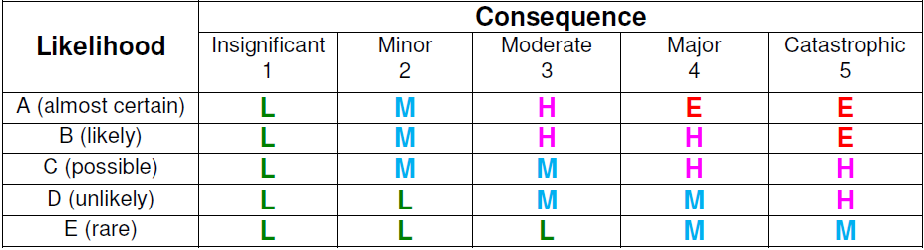

Risk Control Process

Description of risk | Likelihood | Consequence | Risk Rating | Actions | Responsible officer

